Homework 5.5: Graphing Rational Functions Name: ______________________
Math 3

Directions: Answer each of the following multiple choice questions to the best of your ability. Show all necessary work.
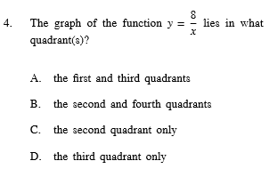
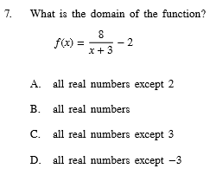
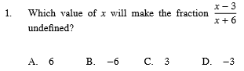

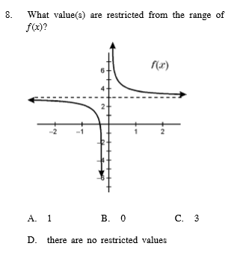
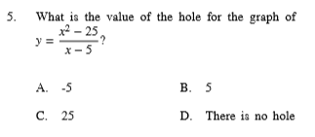
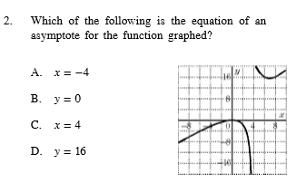

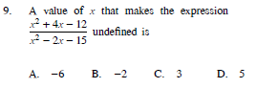
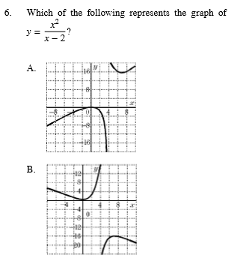
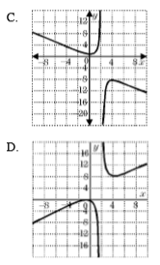
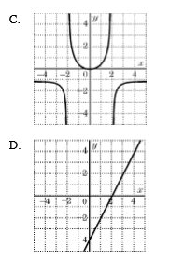
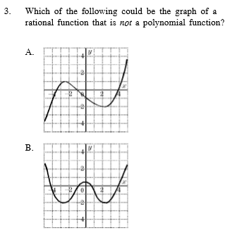

Directions: Identify points of discontinuity, vertical asymptotes, horizontal asymptotes, and x-intercepts. Do not graph the functions.

9. 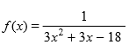
10. 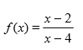
11. 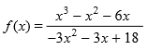
12. 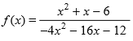

Directions: Identify points of discontinuity, vertical asymptotes, horizontal asymptotes, and x-intercepts. Then, sketch the graph and state the domain.
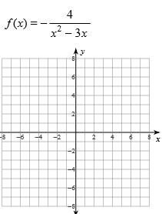

13.
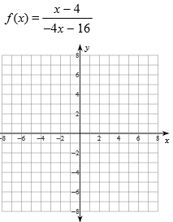
14.
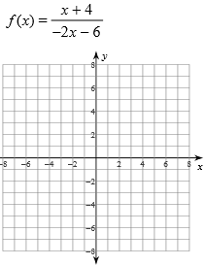
15.
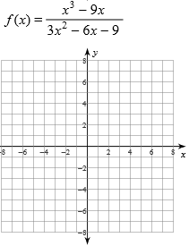
16.

POD:
VA:
HA:
X-int:
Domain:
POD:
VA:
HA:
X-int:
Domain:
POD:
VA:
HA:
X-int:
Domain:
POD:
VA:
HA:
X-int:
Domain:

